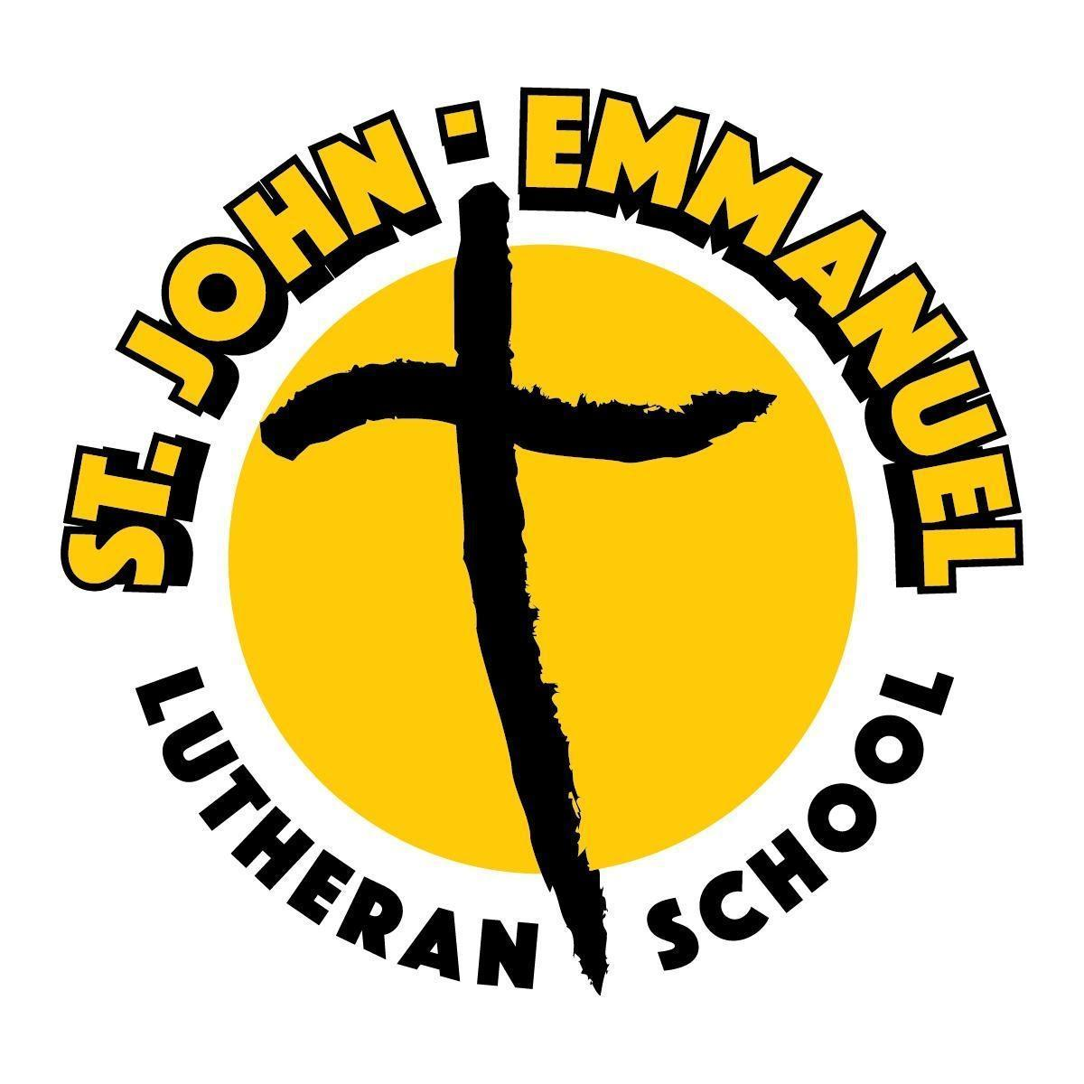
St. John-Emmanuel Lutheran School
2024 Tiger Night Dinner Auction
Western Night
January 27, 2024

John Wayne Event Sponsor - $2,500
- Table of 8 at event
- Company/Family name on table
- Signage displayed at event
- Highlighted throughout the event
- Company listed on first page of program and virtual auction website
- Donation plaque for your business

Jesse James Live Auction Sponsor - $1,500
- Table of 8 at event
- Signage displayed at event
- Highlighted during live auction
- Company/Family name listed as live auction sponsor listed in program/virtual auction website
- Donation plaque for your business

Doc Holliday Saloon Sponsor - $1,000
- Table of 8 at event
- Banner at the bar to be taken home at the end of the night
- Company/Family name listed as bar sponsor in program and virtual auction website

Billy the Kid Silent Auction Table Sponsor - $750
- 4 Complimentary Tickets to the event
- Signage displayed at event
- Company listed as silent auction sponsor listed in program and virtual auction website
- Donation plaque for your business

Annie Oakley Game Sponsor - $500
- 2 Complimentary Tickets to the event
- Signage displayed at event
- Company listed as silent auction sponsor listed in program and virtual auction website
- Donation plaque for your business

Buffalo Bill Dessert Sponsor - $350
- 2 Complimentary Tickets to the event
- Signage displayed at event
- Company/Family name listed in program

Wyatt Earp Program Sponsor- $150
- Company/Family name listed in program

Sponsorship/Registration Form
Thank you for your support of the 2024 Tiger Night Dinner Auction on January 27, 2024. Please complete the form below and return it to the school.
________ John Wayne Sponsor
________ Jesse James Sponsor
________ Doc Holliday Sponsor ________ Wyatt Earp Sponsor
________ Billy the Kid Sponsor
________ Annie Oakley Sponsor
________ Buffalo Bill Sponsor
_________ In lieu of the sponsorships listed above, please accept my donation of $__________________ toward the Tiger Night Auction.
Name: ______________________________________________________________________________________
Business Name (if applicable): ____________________________________________________________
Address: _____________________________________________________________________________________
City: ________________________________________ State: __________ Zip: _____________________
Phone: __________________________________ email: _____________________________________________
Enclosed is my payment of $_______________ Receipt Needed? Y or N
*Table Sponsorship RSVP *
_______ Please donate my table.
_______ The individuals listed below will be seated at my table.
- ______________________________________ email ______________________________________
- ______________________________________ email ______________________________________
- ______________________________________ email ______________________________________
- ______________________________________ email ______________________________________
- ______________________________________ email ______________________________________
- ______________________________________ email ______________________________________
- ______________________________________ email ______________________________________
- ______________________________________ email ______________________________________
Please send your sponsorship/registrations and payment to:
St. John – Emmanuel Lutheran School
Attn: Amy Schlaudroff
12912 Franke Rd
Monroeville, IN 46773
For questions regarding sponsorships, please contact
Annie Sommers 260-450-1194 or TigernightSJE@gmail.com
Office Use - Committee Contact: _________ Date Sent: _____________ Date Received: _____________

